Lab 06 Abstraction and Interfaces

Exercise 1
Question: Abstract Shape with area/perimeter; implement Circle, Rectangle and Square.
Java source code:
abstract class Shape {
abstract double area();

abstract double perimeter();
}

class Circle extends Shape {
double radius;

Circle(double radius) {
this.radius = radius;
}

@Override
double area() {
return Math.PI * radius * radius;
}

@Override
double perimeter() {
return 2 * Math.PI * radius;
}
}

class Rectangle extends Shape {
double width;
double height;

Rectangle(double width, double height) {
this.width = width;
this.height = height;
}

@Override
double area() {
return width * height;
}

@Override
double perimeter() {
return 2 * (width + height);
}
}

class Square extends Shape {
double side;

Square(double side) {
this.side = side;
}

@Override
double area() {
return side * side;
}

@Override
double perimeter() {
return 4 * side;
}
}

public class Exercise1Shapes {
public static void main(String[] args) {
Shape[] shapes = {new Circle(2), new Rectangle(3, 4), new Square(3)};
// Each shape provides its own implementation of these calculations.
for (Shape shape : shapes) {
System.out.printf("Area %.2f, perimeter %.2f%n",
shape.area(), shape.perimeter());
}
}
}

Expected output (sample):
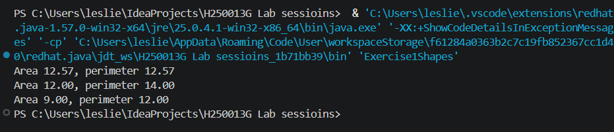Explanation: Shape defines required operations. Each concrete subclass implements its own formulas.

Exercise 2
Question: Create Flyable interface implemented by Bird and Aeroplane.
Java source code:
public class Exercise2Flyable {
interface Flyable { void fly(); }
public static void main(String[] args) {
Flyable[] things = {new Bird(), new Aeroplane()};
// The same interface supports different flying implementations.
for (Flyable thing : things) {
thing.fly();
}
}
}

class Bird implements Exercise2Flyable.Flyable {
@Override
public void fly() {
System.out.println("Bird flies with wings");
}
}

class Aeroplane implements Exercise2Flyable.Flyable {
@Override
public void fly() {
System.out.println("Aeroplane flies with engines");
}
}

Expected output (sample):
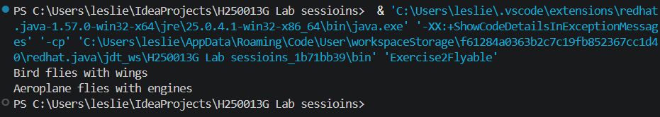Explanation: Both unrelated classes implement the same capability contract, so they can be used through Flyable.

Exercise 3
Question: Abstract Account with deposit() and monthlyFee(); SavingsAccount and CurrentAccount.
Java source code:
abstract class Account {
double balance;

Account(double balance) {
this.balance = balance;
}

void deposit(double amount) {
balance += amount;
}

abstract double monthlyFee();
}

class SavingsAccount extends Account {
SavingsAccount(double balance) {
super(balance);
}

@Override
double monthlyFee() {
return 2.0;
}
}

class CurrentAccount extends Account {
CurrentAccount(double balance) {
super(balance);
}

@Override
double monthlyFee() {
return 5.0;
}
}

public class Exercise3Accounts {
public static void main(String[] args) {
Account savings = new SavingsAccount(100);
savings.deposit(20);
System.out.println("Balance: " + savings.balance
+ ", fee: " + savings.monthlyFee());

Account current = new CurrentAccount(100);
// The fee is selected by the concrete account type.
System.out.println("Current fee: " + current.monthlyFee());
}
}

Expected output (sample):
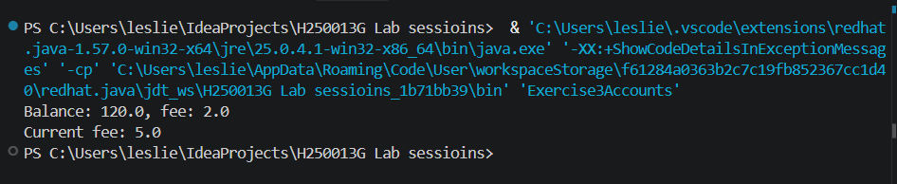Explanation: The abstract class shares balance and deposit(). Subclasses supply their monthly fee.

Exercise 4
Question: Student Comparable by name, plus Comparator by marks.
Java source code:
import java.util.*;

class ComparableStudent implements Comparable<ComparableStudent> {
String name;
int marks;

ComparableStudent(String name, int marks) {
this.name = name;
this.marks = marks;
}

@Override
public int compareTo(ComparableStudent other) {
return name.compareTo(other.name);
}

@Override
public String toString() {
return name + "(" + marks + ")";
}
}

public class Exercise4ComparableStudent {
public static void main(String[] args) {
List<ComparableStudent> students = new ArrayList<>(List.of(
new ComparableStudent("Tariro", 70),
new ComparableStudent("Leslie Sarai", 86),
new ComparableStudent("Rudo", 91)));
Collections.sort(students);
System.out.println("By name: " + students);

// This comparator provides an alternate ordering without changing compareTo.
students.sort(Comparator.comparingInt(student -> student.marks));
System.out.println("By marks: " + students);
}
}

Expected output (sample):
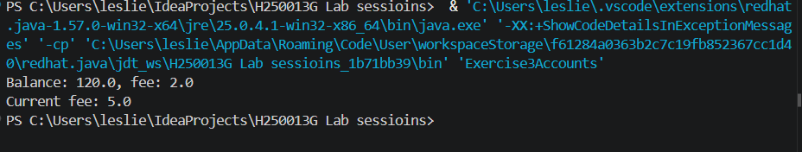Explanation: Comparable defines natural name order. Comparator provides an alternative ordering by marks.

Exercise 5
Question: Resolve two interfaces that both declare default hello().
Java source code:
public class Exercise5DefaultConflict {
interface First {
default void hello() {
System.out.println("Hello from First");
}
}

interface Second {
default void hello() {
System.out.println("Hello from Second");
}
}

public static void main(String[] args) {
new Greeter().hello();
}
}

class Greeter implements Exercise5DefaultConflict.First, Exercise5DefaultConflict.Second {
@Override
public void hello() {
// Resolve the conflict by explicitly invoking both defaults.
Exercise5DefaultConflict.First.super.hello();
Exercise5DefaultConflict.Second.super.hello();
}
}

Expected output (sample):
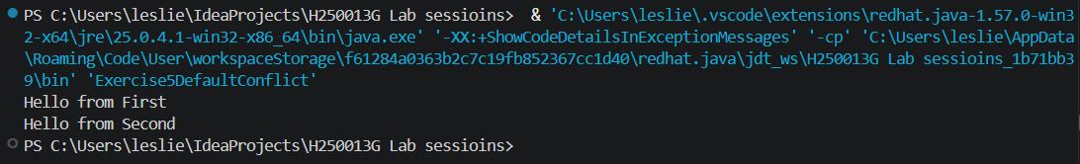Explanation: Java requires the class to override hello() to resolve the conflict. InterfaceName.super selects each default implementation.
.

